Test Case: tc001_SPX_Dev5_Crear_Solicitud_Articulo_Almacen
Step 1 - Enter username and password and click to button Enter : Credentials Entered
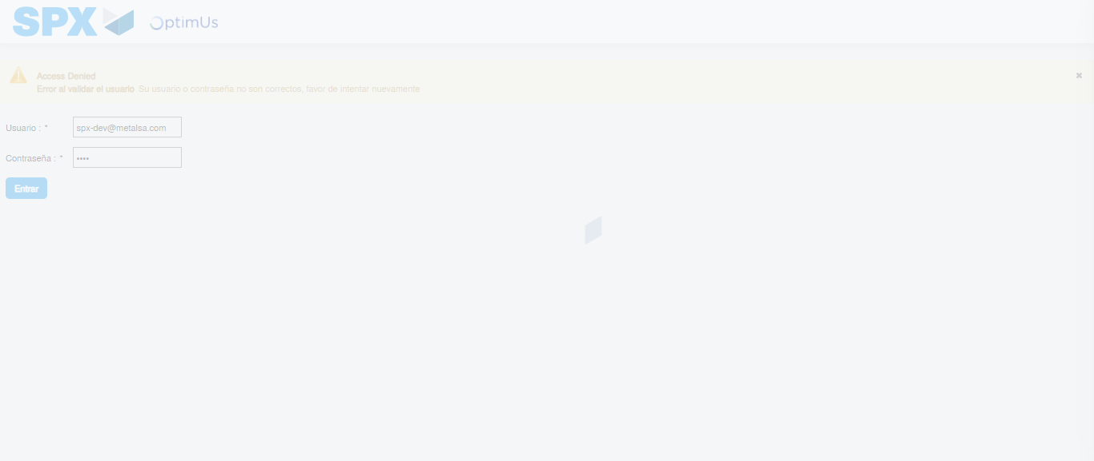Image file-name: QC_Testing-tc001_SPX_Dev5_Crear_Solicitud_Articulo_Almacen-1787935043679

Step 2 - Select to UEN and Access to Request for a New Inventory Item : UEN Correctly selected and Correct access
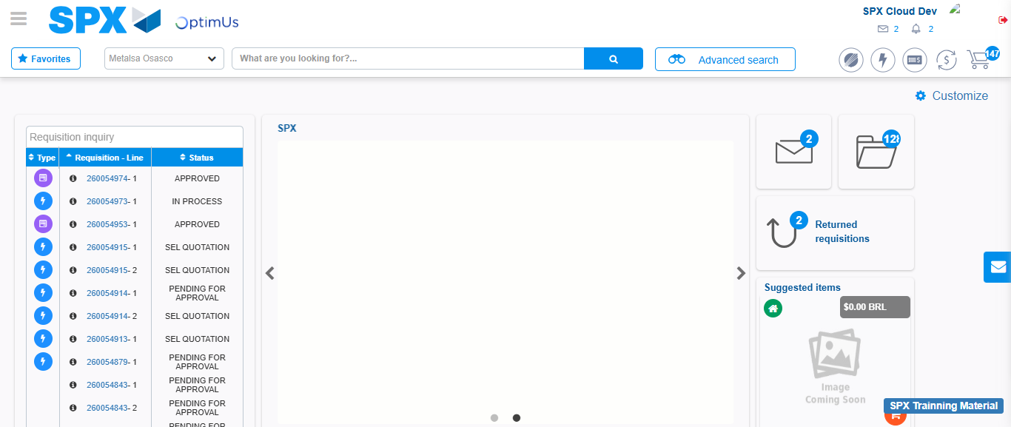Image file-name: QC_Testing-tc001_SPX_Dev5_Crear_Solicitud_Articulo_Almacen-1787935119956

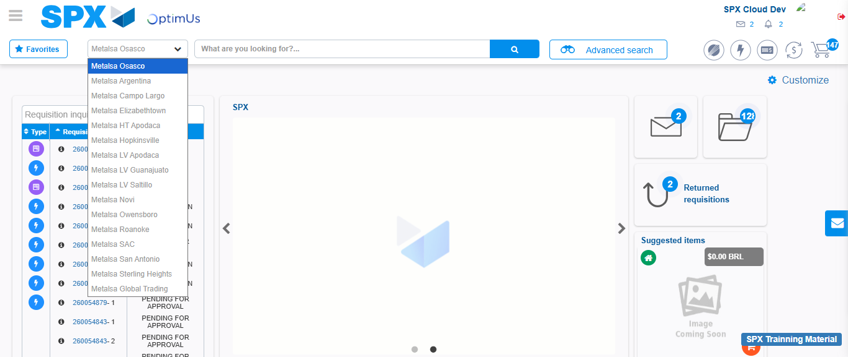Image file-name: QC_Testing-tc001_SPX_Dev5_Crear_Solicitud_Articulo_Almacen-1787935120603

Image file-name: QC_Testing-tc001_SPX_Dev5_Crear_Solicitud_Articulo_Almacen-1787935131943

Step 3 - Select options first section : Options seleted correctly
Image file-name: QC_Testing-tc001_SPX_Dev5_Crear_Solicitud_Articulo_Almacen-1787935132264

Image file-name: QC_Testing-tc001_SPX_Dev5_Crear_Solicitud_Articulo_Almacen-1787935132481

Step 4 - Select options at Screen: Options seleted correctly
Image file-name: QC_Testing-tc001_SPX_Dev5_Crear_Solicitud_Articulo_Almacen-1787935132264

Image file-name: QC_Testing-tc001_SPX_Dev5_Crear_Solicitud_Articulo_Almacen-1787935132481

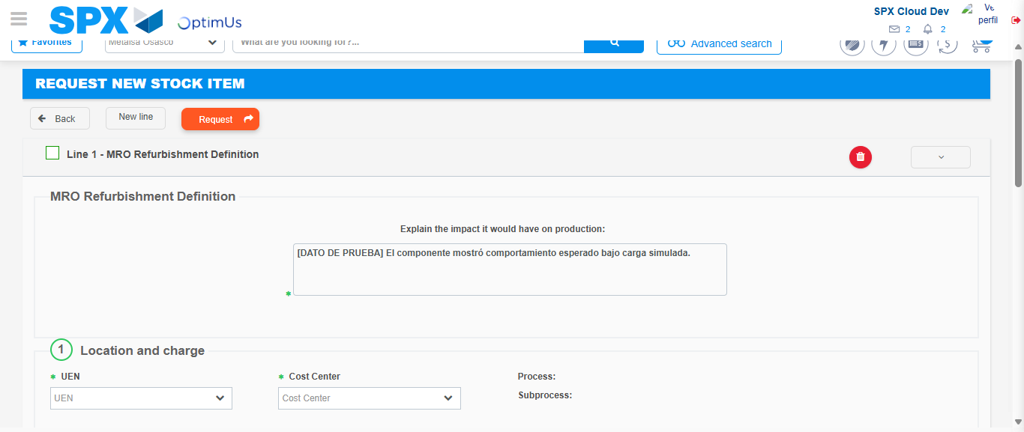Image file-name: QC_Testing-tc001_SPX_Dev5_Crear_Solicitud_Articulo_Almacen-1787935143300

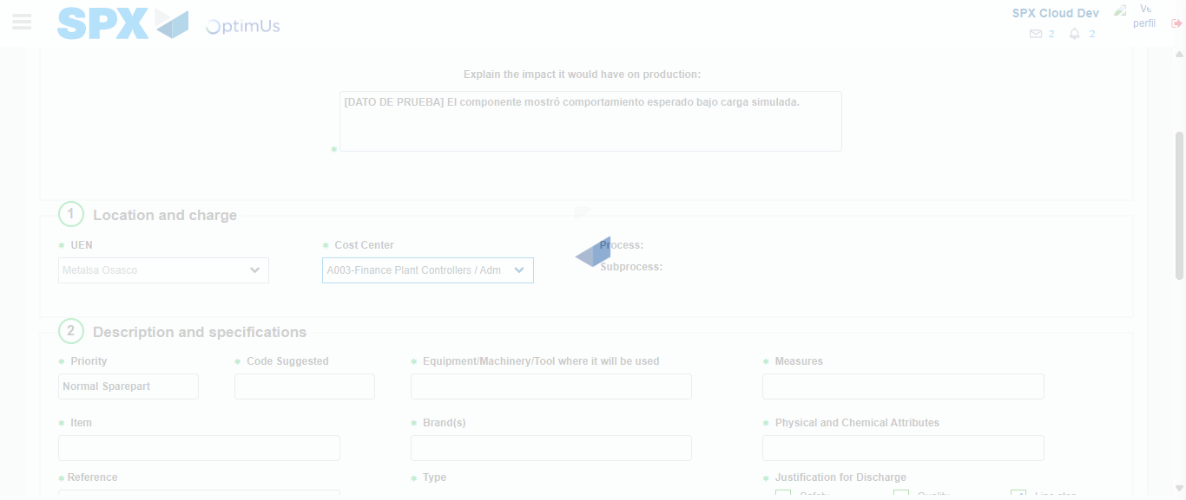Image file-name: QC_Testing-tc001_SPX_Dev5_Crear_Solicitud_Articulo_Almacen-1787935146182

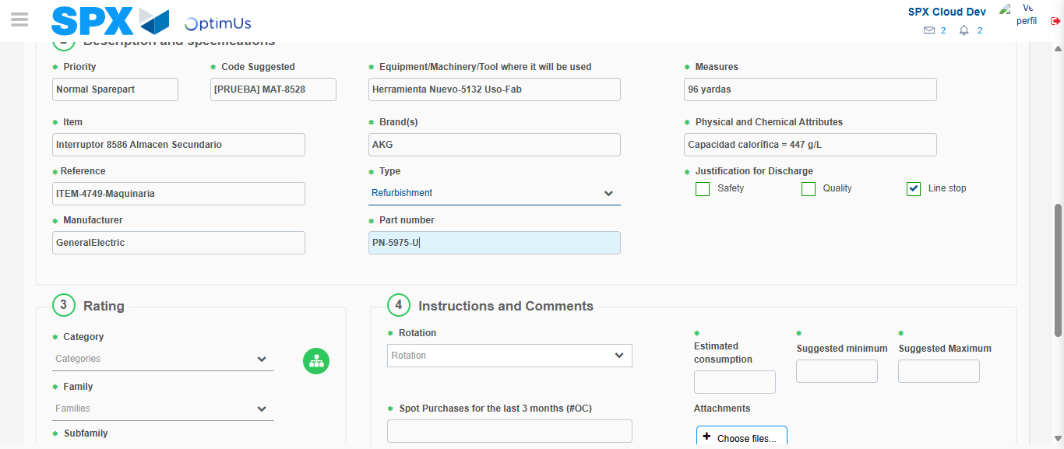Image file-name: QC_Testing-tc001_SPX_Dev5_Crear_Solicitud_Articulo_Almacen-1787935148295

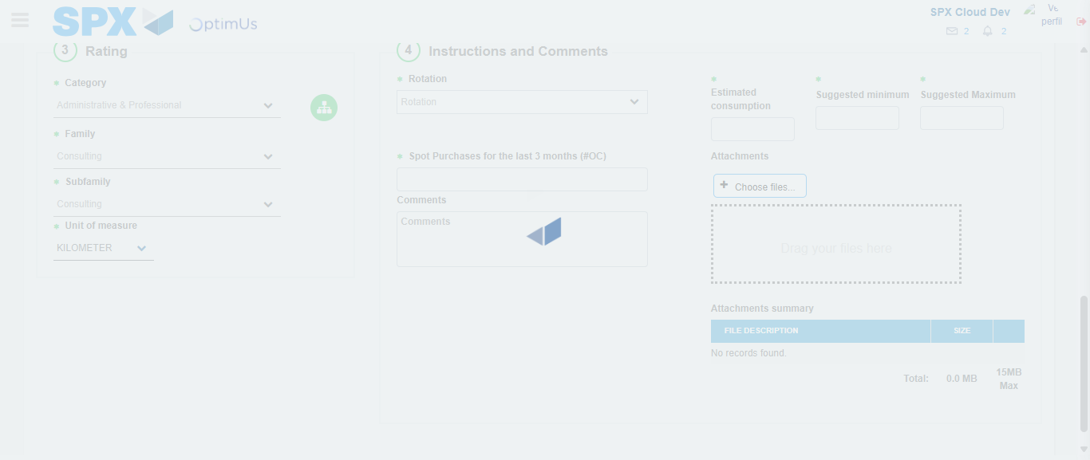Image file-name: QC_Testing-tc001_SPX_Dev5_Crear_Solicitud_Articulo_Almacen-1787935153317

Step 5 - Request New Item : Request Accepted
Image file-name: QC_Testing-tc001_SPX_Dev5_Crear_Solicitud_Articulo_Almacen-1787935119956

Image file-name: QC_Testing-tc001_SPX_Dev5_Crear_Solicitud_Articulo_Almacen-1787935120603

Image file-name: QC_Testing-tc001_SPX_Dev5_Crear_Solicitud_Articulo_Almacen-1787935131943

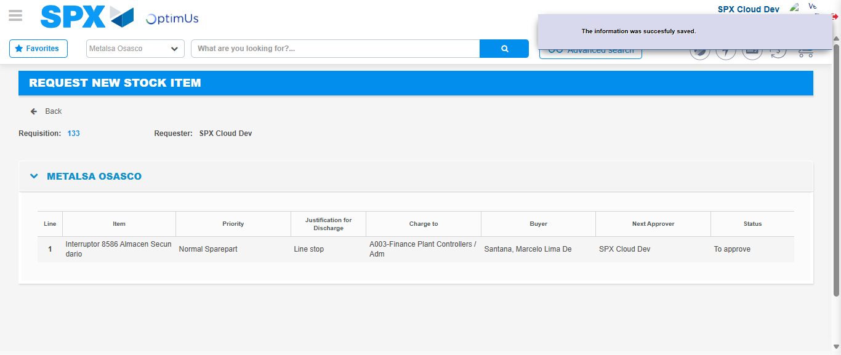Image file-name: QC_Testing-tc001_SPX_Dev5_Crear_Solicitud_Articulo_Almacen-1787935161091

Image file-name: QC_Testing-tc001_SPX_Dev5_Crear_Solicitud_Articulo_Almacen-1787935161343

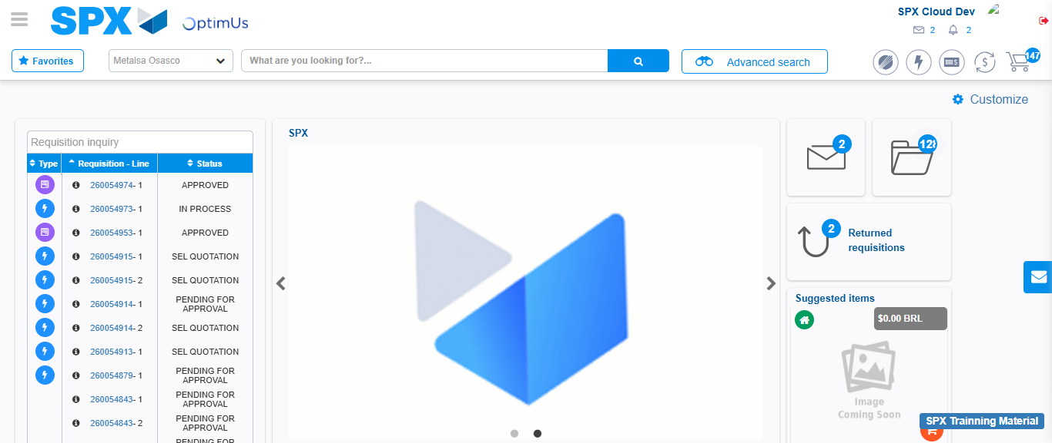Image file-name: QC_Testing-tc001_SPX_Dev5_Crear_Solicitud_Articulo_Almacen-1787935183258

Step 7 - Return to Main Page SPX : Return to Main Page SPX
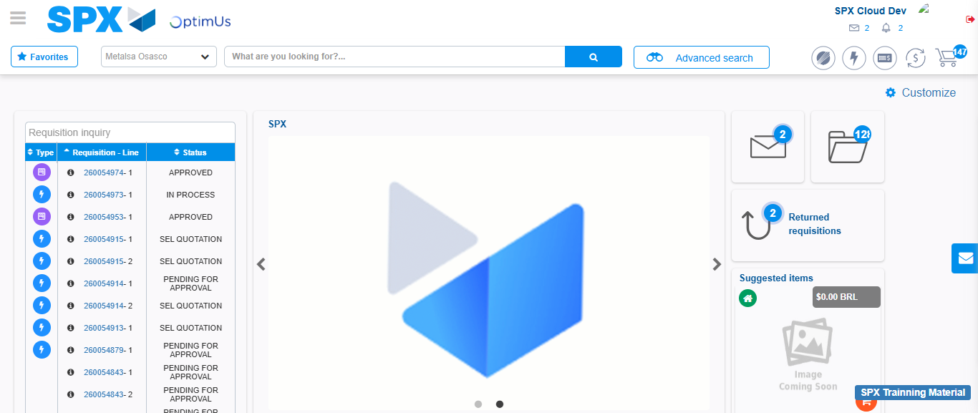Image file-name: QC_Testing-tc001_SPX_Dev5_Crear_Solicitud_Articulo_Almacen-1787935183539

